For emergency access to the airplane, use the emergency exit panel release incorporated in both sides of the fore and aft cockpit enclosures. To obtain access, pull release handle UP until latch pins are free. Then pull OUT on handle to free panels from enclosures. In case of a nose-over, pull handle DOWN, then pull OUT on handle.

Cockpit enclosures can also be opened from the outside by turning knob on the top front of the forward canopy enclosure to the left or right. This releases the enclosure pins allowing canopy to slide aft. Aft cockpit enclosure has the same apparatus but it is located on the top rear of the canopy enclosure. When pins are released, the canopy slides forward.
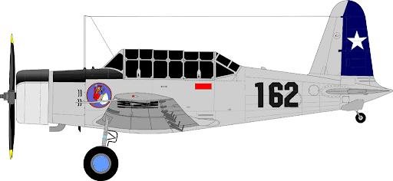

Fire extinguisher is located on panel under rear cockpit. Panel is hinged at the bottom and is opened by releasing the two thumb latches on the top right and top left of the panel. Panel is painted red with white “FIRE EXTINGUISHER” lettering.
